VIDEO CONSULTATION CONSENT FORM
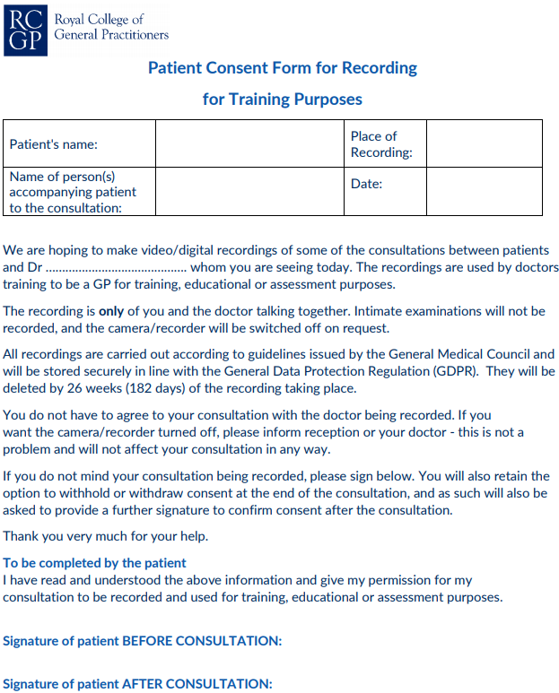
Tweeddale Medical Practice

